Newham Bridge
Primary School

PE Policy

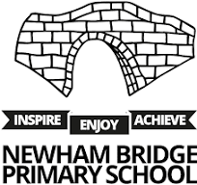

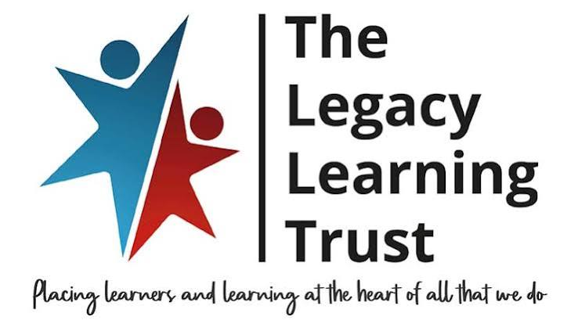

Intent
At Newham Bridge Primary School, our intent is to provide a high-quality Physical Education curriculum that inspires all children to enjoy being active, develop confidence and achieve their personal best.
Physical Development and Fundamental Skills
Movement Competence: Ensure all pupils develop secure and progressive fundamental movement skills including running, jumping, throwing, catching, balance, agility and coordination.
Physical Confidence: Give children the skills and confidence they need to take part in a wide range of physical activities and sports.
Progression: Build learning step by step so pupils can apply and refine their skills with increasing control.
Personal Development and Wellbeing
Resilience and Effort: Encourage pupils at Newham Bridge to challenge themselves, persevere and understand the value of effort and practice.
Teamwork and Respect: Promote cooperation, communication and respect for others in both competitive and collaborative situations.
Confidence Building: Provide opportunities for all children to experience success and develop self-belief through PE and sport.
Enjoyment, Activity and Opportunity
Healthy Lifestyles: Promote the importance of physical activity for both physical health and emotional wellbeing.
Opportunities for All: Ensure every child at Newham Bridge has access to a broad range of sporting experiences, including competition and enrichment activities.
Lifelong Enjoyment: Inspire a lasting enjoyment of physical activity so pupils leave Newham Bridge with the motivation to stay active and healthy in the future.

Curriculum Implementation
At Newham Bridge Primary School, PE is delivered through a broad, balanced and progressive curriculum that ensures all pupils experience the full range of physical activity outlined in the National Curriculum. All children take part in two PE lessons each week, providing regular opportunities to develop skills, fitness and a love of being active. Lessons are carefully planned to develop fundamental movement skills, physical confidence and enjoyment through a variety of sports, games, dance, gymnastics, athletics, outdoor and adventurous activities, and swimming.
PE is taught in a sequenced way so that skills are built upon over time, allowing children to develop increasing control, coordination and understanding. Pupils are given opportunities to apply their skills in both individual and team contexts, with a strong focus on developing cooperation, communication, tactics and fair play.
Lessons include opportunities for pupils to practise and refine skills before applying them in more challenging and competitive situations. Children are encouraged to evaluate their own performance and the performance of others, helping them to understand how to improve and achieve their personal best.
Teaching is inclusive and adapted to meet the needs of all learners, ensuring that every child can access and succeed in PE. Pupils are taught in a variety of groupings, including whole class, small groups, pairs and individual practice, depending on the activity and learning objective. Staff use ongoing assessment to support progression and to ensure children are challenged appropriately.
Opportunities for extra-curricular clubs, festivals and competitions are used to extend learning beyond the curriculum, helping to develop confidence, resilience and a lifelong enjoyment of physical activity.

Impact and Assessment
Assessment Principles and Practices
Assessment in Physical Education at Newham Bridge Primary School is designed to support learning, inform teaching and monitor progress over time. We use a combination of formative to ensure all pupils are developing their knowledge, skills and understanding in PE.
Assessment is based on:
- Observing pupils’ performance during lessons, including skill development, application and participation in activities.
- Questioning and feedback to check understanding of tactics, rules, strategies and healthy participation.
- Evaluating pupils’ ability to work individually, in pairs and in teams, demonstrating cooperation, communication and sportsmanship.
- Self- and peer-assessment, helping pupils to reflect on their performance and identify ways to improve.
Assessment information is used to inform planning, ensure lessons are appropriately challenging and support all pupils to make progress and achieve their personal best.
Monitoring Progression and Coverage
Progression in Physical Education is tracked through medium-term planning and ongoing teacher observations. Teachers ensure that all areas of the PE curriculum are covered, including games, gymnastics, dance, athletics, swimming and outdoor and adventurous activities.
The PE subject leader and senior leadership team monitor progression through learning walks, lesson observations, pupil voice and review of planning and assessment evidence. Where gaps in learning are identified, support is put in place to ensure all pupils continue to make strong progress.

Evaluating and Improving Impact
The impact of the PE curriculum is reviewed regularly throughout the year using evidence from lesson observations, assessment, pupil voice and staff feedback. This information is used to inform future planning, staff development and curriculum improvements.
We ensure that PE provision continues to be high quality, inclusive and engaging, giving all pupils the opportunity to succeed, enjoy physical activity and develop lifelong healthy habits.
Resource Provision, Partnerships and Enrichment
A wide range of resources and opportunities are used to enhance PE learning at Newham Bridge, including:
- High-quality equipment to support a broad range of sports and activities
- Access to indoor and outdoor learning environments
- Extra-curricular clubs and enrichment activities
- Opportunities to represent the school in festivals, competitions and events
- Links with local sports providers and external coaches
These experiences help to broaden pupils’ opportunities, build confidence and develop a lifelong enjoyment of physical activity.

