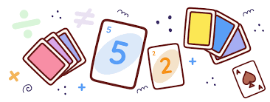
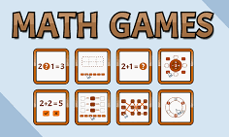
This week we would like you to create your own maths game! Your game will include rolling a dice and then you will need to decide what happens with the number you have rolled.
Will you use that number and then times it by the next number? Will you divide? Will you create a decimal number, will you roll the dice and then move that many places on a board and have a calculation to complete on that space?
You will need to consider the age of the players, how many players can play at one time, what resources your players may need (counters, dice, a board, cards etc).
You get to decide, be as creative as you can!
If you need any resources, please just ask.
We will host a session in school, where we will get time to play each other’s games, so please try to make sure you have something to bring.

