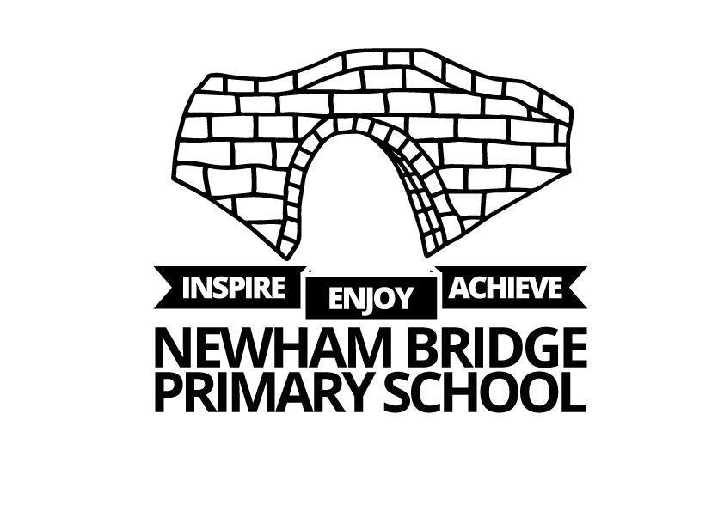
NEWHAM BRIDGE PRIMARY SCHOOL FOUNDATION SUBJECTS CURRICULUM AND ASSESSMENT DOCUMENT
Art

Year One Art Curriculum
Vocabulary | Monochromatic- Collaboration, continuous, doodle, gallery, graphite, line, monochromatic, pressure, represent, shape, tone, value, zigzag.  Chromatic- colour, line, paint, painter, painting, handle, dot, shape, real, abstract, decorate, gallery, inspire, feelings, emotions, primary colours.  Sculpture- create, nature, press, roll, flatten, 3D, emotion, experiment, imprint, layer, inspired, sketch, texture tile, clay, ceramic, coil, kiln, pottery, sculpt, slab, varnish, sculptor.
Skills | Drawing skills- Pupils can understand how to use a pencil and explore pressure and grip. They will know the definition of line and shape and begin to understand the concept of value.  Colour theory- Identifying the 3 primary colours and mixing to make secondary colours. Pupils will learn parts of a brush, controlling the brush, use acrylic paints and rinsing the brush between colours.  Clay techniques- Pupils will know what clay is and where it comes from, they will begin to understand texture, shape it into balls, slabs and coils. They will imprint into clay with different objects.  Collage - create images from a variety of media, arrange and glue materials to different backgrounds, to sort materials for different purposes (colour, shape, texture etc).
Disciplinary and theoretical knowledge | Pupils will begin to learn about artists work worldwide and understand how work is displayed in galleries. They will begin to understand why people draw or create art and how it can create an emotional response. Pupils will be able to evaluate each other’s work and give feedback.

Year Two Art Curriculum
Vocabulary | Monochromatic- Architect, chromatic, decorative, design, designer, drawing, evaluate, experiment, geometric, henna, line, mehndi, monochromatic, organic, pattern, shape, space.  Chromatic- warm, cool, contrast, complementary, elements, the colour wheel, vivid, still life, colour palette, feeling, landscape, evoke, original, portrait, process.  Sculpture- Column, form, ornament, relief, score and slip shape, sketchbook, sphere, spherical, wedging, 2D, 3D
Skills | Drawing skills- Pupils will revise parts of the pencil, control it with increased precision and use a guide to keep drawings more precise. They will know the definition of line, shape and space, explore patterns and how to use scissors correctly for a desired effect.  Colour theory- Pupils will revisit primary and secondary colours. They will identify warm and cool colours, complementary colours and begin to recognise the colour wheel. They will create their own colour palette. They will revise the brush, control with precision and use acrylic paints.  Clay techniques- Pupils will wedge clay to prepare it, use score and slip to join and create a relief design. They will identify how to create brown and grey using primary colours, black and white paint.  Collage- create images from a variety of media, arrange and glue materials to different backgrounds, to sort materials for different purposes (colour, shape, texture etc)
Disciplinary and theoretical knowledge | Pupils will learn about contemporary and historical designers work by learning about a Mehndi artists work and how designers’ impact how our homes look. They will look at designs over thousands of years, décor within the home and patterns within nature. They will consider how we feel about art and why we create it. They will discuss how colours make people feel, understand landscape and portrait and still life. They will evaluate artwork focusing on responses and reflection on the artistic approach.

Year Three Art Curriculum
Vocabulary | Monochromatic- Line, shape, drawing, continuous, highlight, illusion, landscape, bridge, continuous, evaluate, iris, landscape, light source, line, observational drawing, portrait, process, pupil, shape, still life, tear duct, texture, value  Chromatic- watercolour, illustrator, illustration, paint pan, blend, observational, observe, medium, blending, brushstroke, composition, creativity, techniques, texture, transparent, famous, acrylic, illustrator, realism.  Sculpture- Blend, mould, pinch pot, pottery, ceramic, column, experiment, impact, imprint, influence, inspired, relief, sphere, texture, clay, climate, pinch pot, pottery, score and slip, varnish, wedging, primary colours, sculpture, secondary colours.
Skills | Drawing skills- Pupils will revisit Year 2 skills. They will explore how marks can create the impression of texture, how lines and shapes create facial features and use value and texture to create desired outcome. They will use shapes to support drawing and learn from observing.  Colour theory- Pupils will visit primary, secondary and complementary colours and begin to blend colours together. Pupils will revisit parts of a brush, use it with increased precision and learn how to use watercolours.  Clay techniques- Pupils will create a pinch pot and mould a 3D plant sculpture. Pupils will identify shapes in plants and understand the definition of shape.  Collage- work on a range of different scales, with different materials exploring texture and overlapping.
Disciplinary and theoretical knowledge | Pupils must understand that artists must practise specific skills to improve and how artists can represent facial features differently. They explore connections between art and emotions. They will understand how art can impact a society and how technology can influence art. They will formally respond to a piece of art and evaluate their own work. Pupils will learn about how location influenced a diverse artists and craft makers.

Year Four Art Curriculum
Vocabulary | Monochromatic- atmospheric perspective, colour perspective,  cross-hatching, drawing, evaluate, experiment, form, gradient, hatching, horizon, inspiration, linear, one-point perspective, perspective, shape, stippling, value, vanishing point  Chromatic- architect, architecture, drafting, photocollage, collagist, mixed media, context, medium, sketchbook, annotating,  urban, process, form, texture  Sculpture- Coiling, coil pot, hand-building
Skills | Drawing skills- Pupils will revisit Year 3 skills. They will explore how marks can create the impression of texture, how lines and shapes create facial features and use value and texture to create desired outcome. They will use shapes to support drawing and learn from observing.  Colour theory- Pupils will visit primary, secondary and complementary colours and begin to blend colours together. Pupils will revisit parts of a brush, use it with increased precision and learn how to use watercolours.  Clay techniques- Pupils will create a pinch pot and mould a 3D plant sculpture. Pupils will identify shapes in plants and understand the definition of shape.  Collage- work on a range of different scales, with different materials exploring texture and overlapping.
Disciplinary and theoretical knowledge | Pupils will understand that art can involve experimentation, sketchbooks are used for a purpose and that art can reflect what life was like a long time ago. Pupils will discuss what makes an artist successful and what it means to be inspired by others. They should recognise how architects can respond to current issues and how a piece of art can help others to understand it. Pupils will know that art can reflect societal and/or religious beliefs.

Year Five Art Curriculum
Vocabulary | Monochromatic- abstract, angular, body, bold, composed, distorted, form, geometric, graphite, hyperrealism, inspired, line, mixed media, monochromatic, organic, perspective, shape, simplistic, stylised, texture, value  Chromatic- colour, commissioned, composition, form, line, miniaturist, mixed media, opaque, portrait, proportion, shape, sitter, space, texture, value, cartoon  Sculpture- Earthenware clay, stoneware clay, ball clay, porcelain, malleable, kneading, glossy.
Skills | Drawing skills- Pupils will revisit Year 4 skills. They will use observational skills to notice details within a piece of monochromatic work. They will use shape to guide their observational drawings. Pupils will select different pencils for different effects, use proportion when drawing and draw in a geometric style.  Colour theory- Pupils will visit primary and secondary colours to learn how to mix skin tones. Pupils will revisit parts of a brush, use it with increased precision and understand the difference between acrylic and watercolour paint.  Clay techniques- Pupils will create a pinch pot and mould a 3D plant sculpture. Pupils will also learn the four different types of clay and will mould clay with a focus on delicacy and precision. They will create tints, shades and tones with paint and know the analogous colours are.  Collage- develop skills in stitching, cutting and joining.
Disciplinary and theoretical knowledge | Pupils will learn that artists have an artistic style and explore how they can develop their own style. They will describe the style of artworks with appropriate vocabulary; understand it doesn’t need to be realistic and develop an understanding of what the definition of art is. Pupils can use the seven elements of art to talk about artwork, decide how much artwork is worth and learn about portraiture as a form of art over time. They will learn how flowers have influence artists and evaluate others work.

Year Six Art Curriculum
Vocabulary | Monochromatic- cupid’s bow, form, geometric, graphite, horizontal, iris, nose bridge, observe, organic, philtrum, portrait, proportion, pupil, reference material, shape, tear duct, value, vertical, graphite, monochromatic, geometric  Chromatic- composition, proportion, realistic, rubbing, symbol, synthetic, transfer, trace, translucent, collage, form, sustainable conceptual, protest, climate change, geometric, photo-realistic, sustainability, mixed media, acrylic, contemporary  Sculpture- Earthenware clay, stoneware clay, ball clay, porcelain, malleable, kneading, glossy, ceramic, hand-building, kiln, kneading, hyper-realistic, sculpture, tertiary colours, varnish, colour palette
Skills | Drawing skills- Pupils will revisit Year 5 skills. They will use observational skills when drawing and select different pencils for a desired effect. They will use proportion when drawing and use shapes to guide their drawing.  Colour theory- Pupils will should use precision in collage and use the elements of art in their design. They should use pencil to transfer a design sketch and use the grid method to transfer an image. Pupils will use watercolour paints with proficiency.  Clay techniques- Pupils will demonstrate proficiency with clay, design a sculpture and consider the emotional response created. They can sculpt clay around something like foil, to build larger sculptures.  Collage- Experiment with a range of materials and textiles, developing overlapping and layering techniques
Disciplinary and theoretical knowledge | Pupils will develop a vocabulary to describe common errors made in realism portraits and recognise that art can be practised and improved on. They will learn about artists from around the world. They will evaluate their work as well as others, understand how art can impact society and recognise that it doesn’t have to be realistic. They will consider the sustainability of art and design and recognise it can be political or for a charitable cause. They will understand what can influence artists and that they can have a recognisable style. They will know how artists have been inspired by food over thousands of years to depict different messages.

