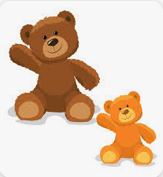
Maths Homework - Size sorting – Big or small
Ask your child to find things around the house and sort out their sizes – big or small. Ask them to draw what they have found.
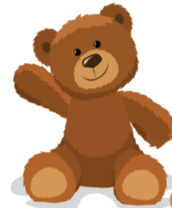
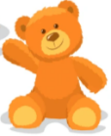
big
small

