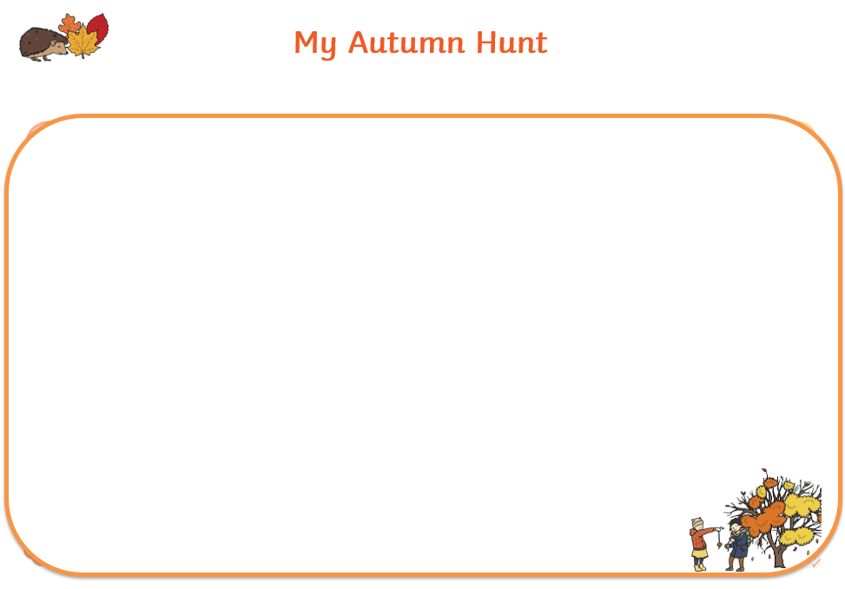
Autumn is a great time of year to enjoy a crisp walk to talk about colours and seasonal changes around us. Go on an Autumn walk with a grown up and collect some autumn treasures like, coloured leaves, pinecones, acorns, conkers and sticks. Put them in the bag provided. Draw the things you collected on the sheet .

